BIG DATA LAB _3

Aggregate functions

Count function
db.praneeth.aggregate([{$match:{dept:"ise"}},{$count:"Total no of students in dept ise:"}])
Greater than
db.praneeth.aggregate([{$match:{salary:{$gt:25000}}}])


Less than
db.praneeth.aggregate([{$match:{salary:{$lt:25000}}}])

Max marks from each dept:
db.praneeth.aggregate({$group:{_id:"$dept",max_marks:{$max:"$salary"}}})
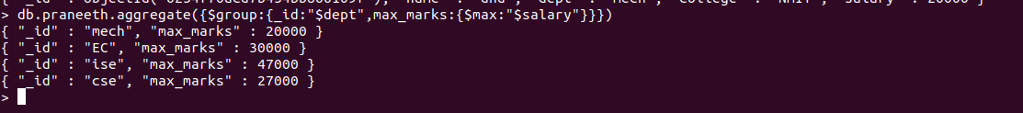

Total salary
db.praneeth.aggregate([ { $group: { _id: null, total: { $sum: "$salary" } } } ] )
Sort

Increasing order:
db.praneeth.aggregate({"$sort":{"salary":1}}).pretty()
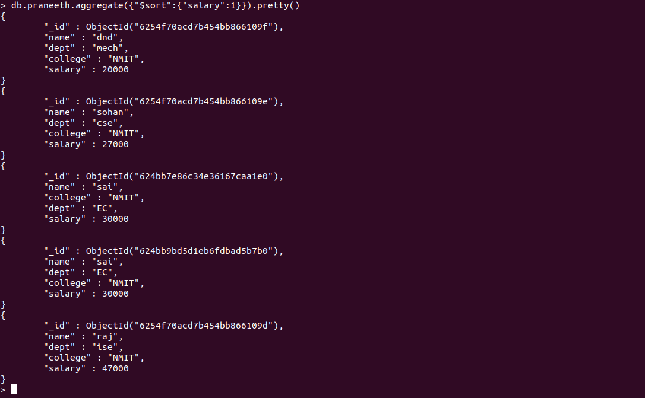
Decreasing order:
db.praneeth.aggregate({"$sort":{"salary":-1}}).pretty()
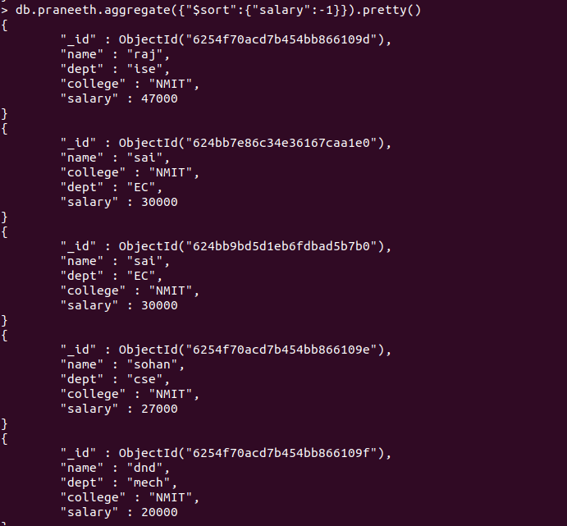

Avg salary:
db.praneeth.aggregate([ { $group: { _id: null, avg: { $avg: "$salary" } } } ] )

